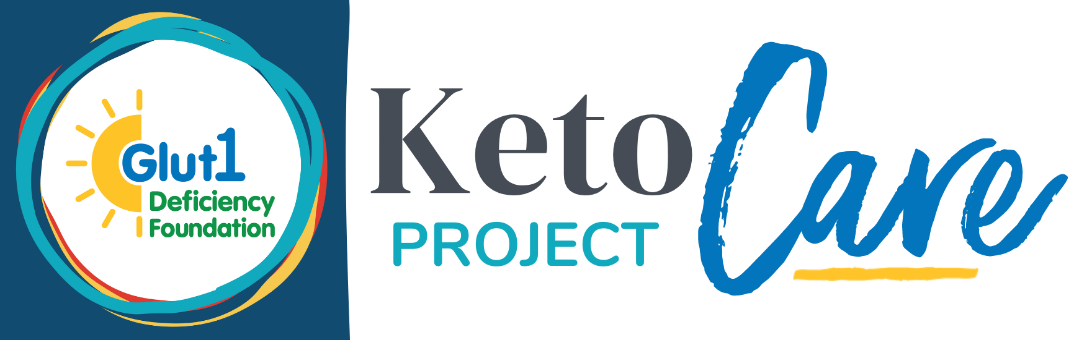

Glut1 Deficiency is a rare, metabolic condition where glucose transport into the brain is impaired, causing a wide range of neurological symptoms. Ketogenic diets are the current standard of care.

Not all patients have access to ketogenic clinics or high quality ketogenic diet support. The goal of the Keto Care Project is to provide expert ketogenic dietitian care to underserved patients and families.
Learn more at the Glut1 Deficiency Foundation website.

Neurologist Referral Form for Full Support Services

INFORMATION:
Patient First and Last Name:
Patient Age:
Patient Address:
Neurologist Name:

Neurologist Address:
Neurologist Email:
Neurologist Phone Number:
CONFIRMATIONS:
____ The patient being referred has a confirmed Glut1 Deficiency diagnosis.
How was the diagnosis confirmed? (check all that apply):
____ genetic testing ____ lumbar puncture ____ METAGlut1 test ____red blood cell uptake assay

I further confirm:
____ There are no ketogenic dietitian services available to my patient through my center of care.
____ I agree to coordinate care with the dietitian consultant through the Keto Care Project.
____ I agree to order blood work, write prescriptions, and help secure insurance coverage as appropriate for
coordinated care.

Neurologist Signature:

Date:

Additional Information: (optional)

